User Panel/ Interaction Section:

1. Departure Location and Destination (Input)

Description: The name of District from where the bus journey will start and the desired destination will be taken from user. It will be used to match with routes of the buses. The bus departure point in the city will be selected while purchasing the ticket. Both inputs are mandatory.

1. Date of departure (must), Return Date(Optional)
2. Description: Date of journey is also another mandatory field of input. As the bus availability depends on the dates and time.
3. Search Buses according to given information.

Description: With the above mandatory info from user, the search result of available buses according to date will be displayed to user.

1. Modifying Search (Filtered by Operator, Bus type, Boarding)

Description: After having the initial result an user may modify the search result with various filters like:- Bus type (Ac/ Non Ac), Bus operator(several bus companies), Time(time range like morning , afternoon, night time).

1. Viewing Searched/Modified Buses in a list (the columns include Bus Operator, Departure time, Arrival time, Available seats, Ticket price )
2. Showing seat plan of a selected bus.
3. Showing the allocated and available seats.
4. Selecting seat(s) (Maximum 4 seats) and boarding point
5. Viewing total ticket price

Description:After selecting seats ,total price will be shown in User interface.

1. For buying tickets: passenger information(name, contact information) and payment information is required

Description: users are required to fill up their information in user interface. Payment information is the payment way in which a user is going to pay (bkash, visa etc)

1. A dummy payment system

Description: After seat selection and filling passenger information,passenger must pay the price.Here we will build a dummy payment system.

1. Ticket Cancellation System:

Description: User can cancel his ticket before a fixed time from departure time.Passenger will be paid back after a certain time.

Admin Section:

1. **Multiple Bus Company**  
   Desc: There should be multiple bus operator in admin panel, each bus operator can set their own routes , ticket pricing, trips per day, trip schedule which include departure and estimated arrival >>Either this admin system or >> any admin can set, modify any in relative information (creating and modifying routes, ticket pricing, trips per day, trips schedule)
2. **Multiple Routes**

Description: Admin can add multiple routes. E.g. From boarding to destination there will be multiple stoppages , ticket pricing will be related according to stoppage, in a broader scenario: A bus departs from Dhaka to Khulna via Faridpur, Magura, Jessore then Khulna. There should a fixed fare from from Dhaka to Jessore , any passenger must pay the fixed amount wherever he wants to travel between this two routes, if the travel distance exceeds Jessore stoppage, then the passenger has to pay more for any stoppage between Jessore to Khulna .

1. **Tripwise seat allocation**  
   Desc: Admin can allocate number of seats in a particular trip. E.g. Shohag Paribahan have a trip from Dhaka to Khulna at 7am in the morning, admin can set number of available seats for customers in that trip, Admin can change number of allocated seats, but if the any seat is already bought or locked down for buying admin can’t dislocate the seat.
2. **Ticket Pricing**   
   Desc: An admin can set the fare, fare can be set according to route plan, ticket pricing is related to route plan, which is discussed in Multiple Routes section.

## 

## 

## 

## **Operational Specification (Details)**

### **User Panel**

**1.Home Page:**

When user visits our website for buying ticket he will see a input form. There will be 3 input fields and a button. Input fields are **From** ,**To** and **Departure Date**.All input fields are mandatory. **From** and **To** input fields will take name of place as a input and both will show suggestion for place.**Departure Date** take date as a input. When user click on that input field ,a calendar will appear and user have to choose date from that calendar.

**Input**:From,To,Departure Date(Required)

**Output**:Search Result(List of buses which meets user’s requirement)

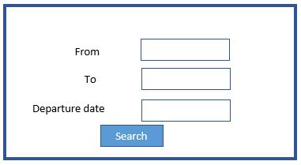

**2.Search result:**

After giving the above input, the available buses will be shown.

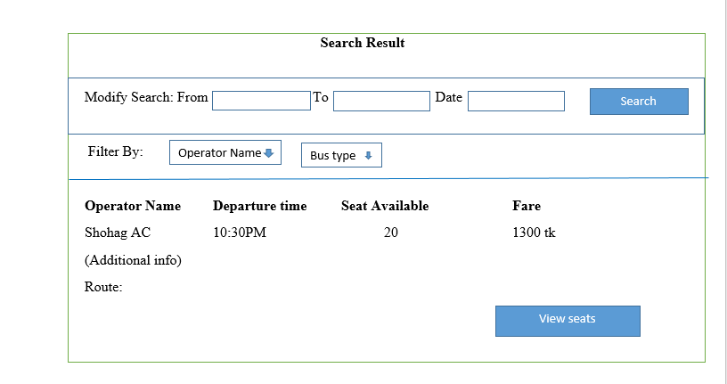

**3.Modify Search:**

User can modify his/her search inputs. New search result will be shown in **Search Result**.

**Input**:From,To,Departure Date(Required)

**Output**:Search Result(List of buses which meets user’s requirement)

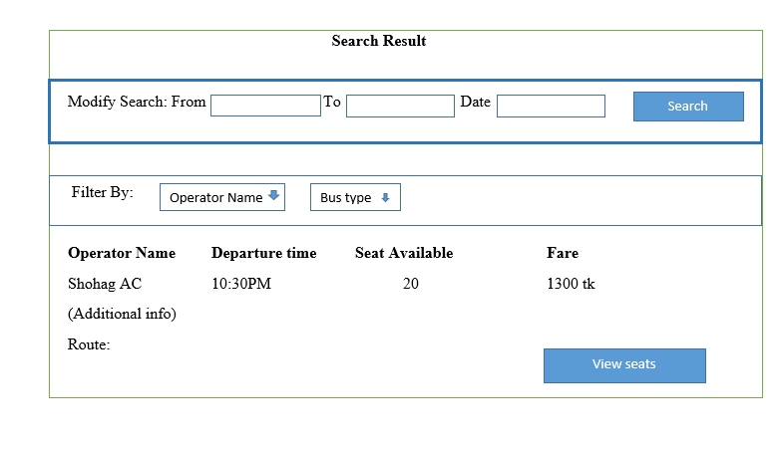

**4.Filter By:**

User can filter from the Search Result. User Can choose **Operator Name** and **Bus Type** from two select box. Filtered list of buses will be appeared in Search Result automatically.

User can see available seats of desired bus trip by clicking on **View Seat.**

**Input**:Operator Name,Bus type

**Output**:Search Result(List of buses which meets user’s requirement)

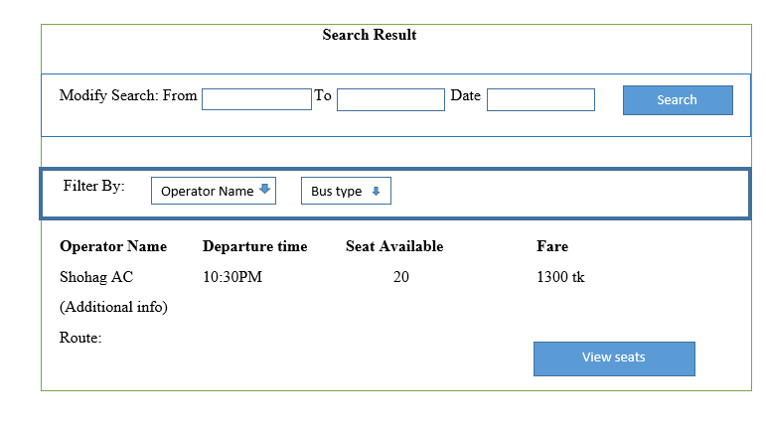

**5.View Seats:**

When user click on **View Seat** button of a particular bus from the **Search Result,** a new window appear which is **Choose Seat.** Here a layout of a bus will be given for helping user to choose desired seats. A multiple select dropdownlist named **Select Seat,** will be there for seat selection.

Only available seats will be there in **Select Seat.**Per seat price will be shown in **Fare Per Seat**. When user select desired number of seats ,total price will be shown in **Total Fare** section.After selection user will click on **Continue Purchase** which will direct user to a new window.

**Input:**Seat Selection

**Output**: Purchase window

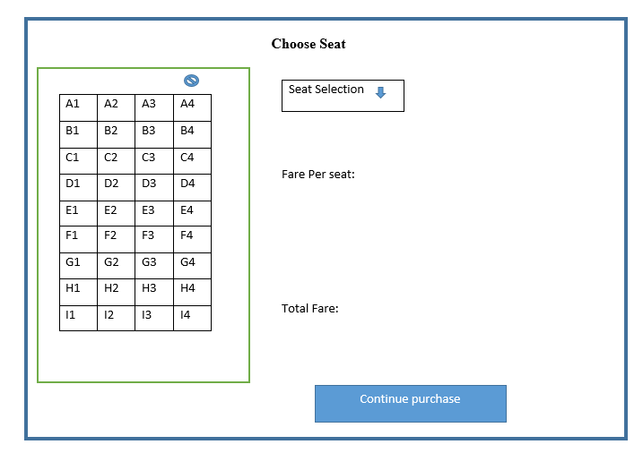

**6. Purchase:**

After selection of seats,user will give some information and pay the price. For this reason

a form will appear.There will be three sections:**Ticket Information**,**Passenger Information** and **Payment information.**

**Ticket Information:** In this section there will be two field: **Purchased Seat** and **Total Price.**The selected seats,user want to buy will be shown in **Purchased Seat**. Total Ticket price will be shown in **Total Price.**

**Passenger Information:** In this section there will be four input fields:**Name**,**Gender,Cell No** and **Email.Name**,**Gender** and **Cell No** are required fields.

**Payment Information:**In this section user will give credit card number for purchase ticket.

After filling all required field user have to click on **Confirm Purchase.** If transaction is successful a new window will appear. Otherwise it will redirect to this **Purchase** window.

**Input**:Name,Gender,Cell No, Email and Credit Card No.

**Output**:Purchased Ticket

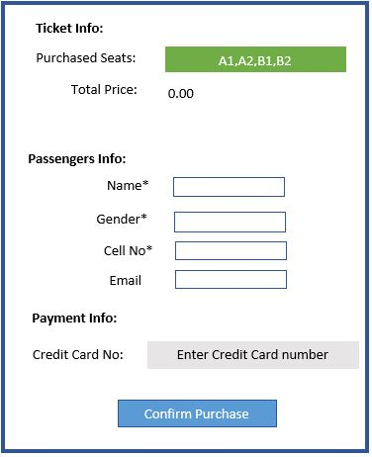

**7.Purchased Ticket:**

In this window Ticket PIN, Passenger Name ,Purchased seats and Total Price will be shown.

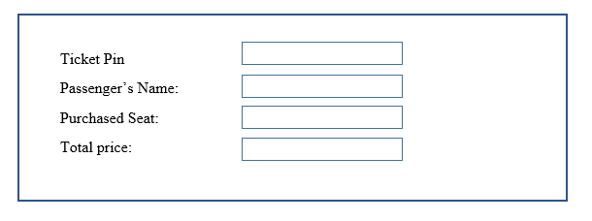

**8.Cancel Ticket:**

User can cancel ticket before fixed time from bus departure time. Here User have to input **Ticket PIN** and **Cell No**. Then user have to click **Cancel Ticket.**

**Input**: Ticket Identity Number,Contact No

**Output**: Confirm Cancel

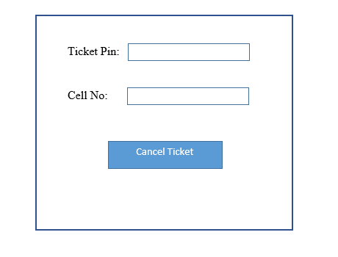

A new window will appear. In this window Ticket PIN, Passenger Name ,Purchased seats and Total Price will be shown.If user want to cancel ticket he/she have to click **Confirm Cancel.**

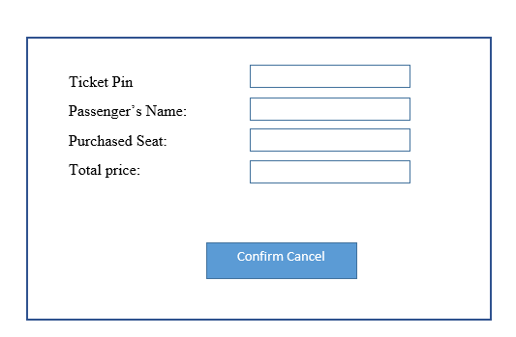

**Admin Panel:**1. **Log in** : Admin has to go through a login page for further administration access. An **username** and **password** is required to login.

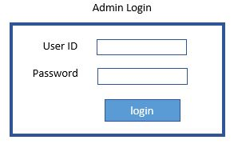  
  
2. **Admin Dashboard** : After successful login admin will be redirected to a dashboard. Admin dashboard contains :  
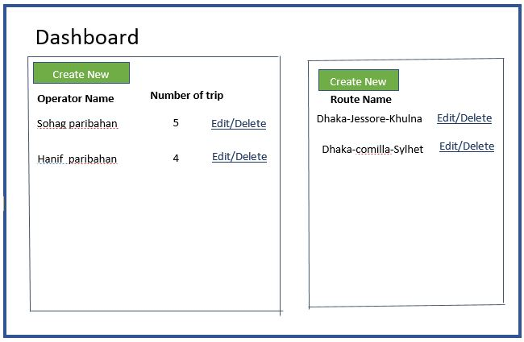

* A **Operator Gridview** of available bus operators with their number of trips, an **Edit**, **Delete** button will be assigned against each operator (gridview row). Above the grid view there will be a **Create New** button which will hold the functionality to create a new bus operator.
  + If the **Create New** button is hit ,

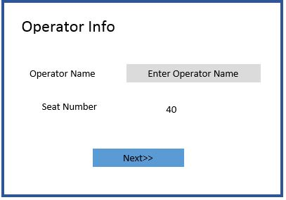

* + - it will redirect to new view, **Operator Info** view . This view contains a **input** text field which will take operators name, A **label** will be provided to show the **a** **fixed** number of seats for all trips for that operator. At the bottom there will be a **Next** button, which will redirect to another **View** for operator details information submission.

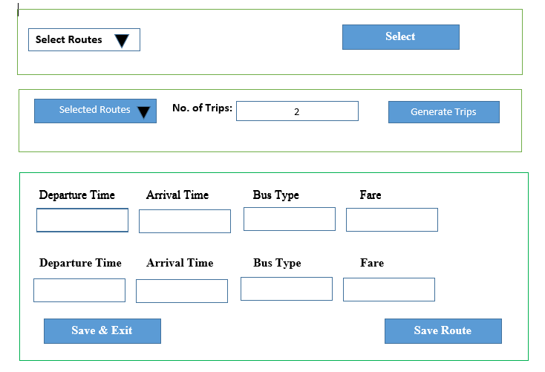

* + - In the **Details Info View**, there will be a multiselect **Dropdown List** which will contain all the available routes, admin can choose any routes(s) for the new operator. 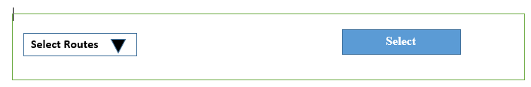
    - Next to the dropdown list a **Select** button will be provided, if this button is hit a **Single Select** **Dropdown List** will load all the selected routes, a **Input** field will be provided next to this dropdown list,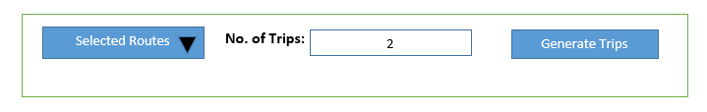 which will take number of trips for the **selected** route in the dropdown list, then a **Generate Trip** button next to the input field should be hit, which will trigger **three input field** for for each trip.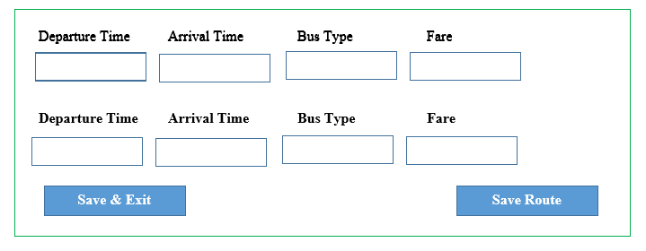 A **Save Route** button will be provided to save the trips information for current selected routes in single select dropdown list. From selecting a single route in Single Select Dropdown List to Save button is a cycle to input details information for a single route. For each selected route, this cycle has to be completed. At the left bottom there’ll be a **Save and Exit** button which will redirect to dashboard.
  + If the **Edit** button is hit,
    - It will redirect to **Operator Info** view, which is the same view for Create button action. The rest of the edit operation is same as the Create New procedure. But for edit action all the input fields and dropdowns will be initially loaded with current information of the operator respectively.
  + If the **Delete** button is hit, it will delete the current row of the grid view, and refresh the list with available operators list.
* A **Available Routes Gridview** will show available routes . An **Edit**, **Delete** button will be assigned against each route (gridview row). Above the gridview there will be a **Create New** button.
  + If the **Create New** button is hit, it will redirect to a new view named **Route Info** view. Three consecutive **input text field** will be provided. First input field is for **Boarding(From)**, the second input field is for **Via** and the third input field is for **Destination**. A **Save** button will be provided at the left bottom, if this button is hit all text in the input fields will saved as a route and page will be refreshed to take new input. Save button won’t work if the first and last input field is null, the second input field (Via) can be null. There will be **Back to dashboard** button at the right bottom.

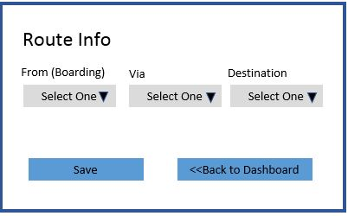

* + If the **Edit** button is hit it will redirect to the view **Route Info.** This is same view where Create New button action redirects. The rest of the edit operation will be same as Create New operation except initially the input fields will be loaded with current route values(From, Via, Destination).
* **Log Out** button will be placed at top right corner, which will logout current session if hit and redirect to login page.